Beat the bustle in Mudgee and find stillness, nature and relaxation
Sinking down into an outdoor tub at sunset the “must sees” and “must dos” of Mudgee feel less urgent. But there is one restaurant you absolutely should not miss.
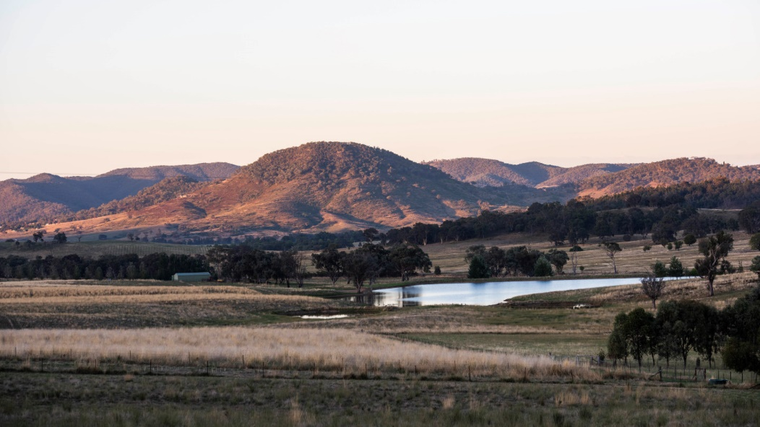
Mudgee’s mineral-rich, fertile land and rolling hills.
Jessica GardnerNews director
Apr 27, 2023 – 5.00am
Save
Share
From the moment I sink into the rustic outdoor bath I start striking “must sees” and “must dos” from my mental itinerary.
It’s a late Friday afternoon and I am up to my shoulders in warm water, sipping a glass of local sparkling wine and pondering a peaceful country scene. Soaring eucalypts tower over our little patch of farm and purple-bottomed clouds float on a horizon of undulating hills. A fire pit crackles, some kangaroos bound by and the dusk chorus of the bush rises up.
It is my first time in Mudgee, and I’ve had big plans for a weekend hustling around cellar doors, poking through posh homewares stores and partaking in many meals.
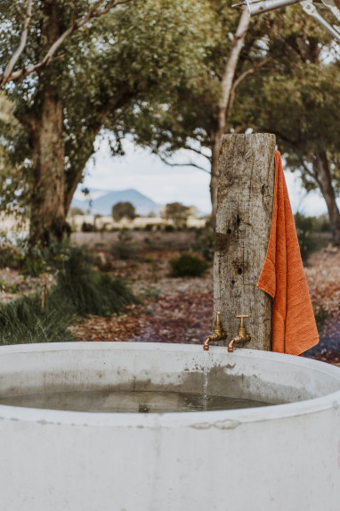
Each tent at Evamor Valley has an outdoor concrete hot tub. The perfect vantage point to watch the sun set. Amber Creative
But since arriving at Evamor Valley, my mood has shifted. A stroll seemed in order while the thousand-litre concrete tub filled, and now, in the warmth of the water, the only thing on my mind is the flock of swallows that dip and dive as the sun lowers in the sky.
There is something about the prospect of spending two nights in a luxurious tent that changes the game: less bustle, more relaxation. It is time for stillness and nature.
In other ways the decision has been made for us. In a fairly last-minute plan, my partner and I have driven five hours north from Canberra for a break in the middle of school holidays, and Mudgee, in central west NSW, is quite busy. Some restaurants cannot fit us in, the town’s bike hire outfit is booked out and an upmarket wine delivery service sadly has no capacity to swing tent-side.
But this should not be a surprise. Mudgee has long been high on the radar for city mini-breakers, and this has only been bolstered by the regional renaissance fuelled during the pandemic. A 3½-hour drive or 45-minute flight from Sydney and packed with wining and dining options, Mudgee is a poorly kept secret.
About 691,000 visitors popped by in 2019 – when data was last recorded – and Spendmapp suggests Mudgee visitors spent 60 per cent more in 2022 than in pre-pandemic years.
About 12,500 people live in town, and about double that in the mineral-rich and fertile surrounds that the Indigenous inhabitants called Moothi, meaning ‘nest in the hills’. Mining accounts for more than half of the $7 billion of the region’s annual economic output. But it’s viticulture and agriculture that provides the charm.
Advertisement
Every plot of land outside town seems productive. Driving there and back, we see sheep, cattle, alpacas, olive groves, orchards – and vineyards. So many vineyards.
Acres of vineyards with histories stretching back to the mid-1800s have fuelled Mudgee’s status as a wine capital. The fertile land and cool climate were originally known for producing robust reds like cabernet sauvignon and shiraz, and chardonnays (which the local wine board promises can be creamy and buttery but all I tasted was stonefruit, alack). But lately the 35 cellar doors have brought other varietals like riesling, tempranillo and sangiovese to the fore.
With the wine has come a fine cafe culture and plenty of places to stay that speak to Mudgee’s historical and agricultural character. At the top end is Perry Street Hotel, offering upscale lodgings in the former mechanics’ institute, built in the 1800s. There are boutique hotels dotted through town and quite a few quaint but lavish farm guest houses such as Farmers Quarters and Hepburn Retreat.
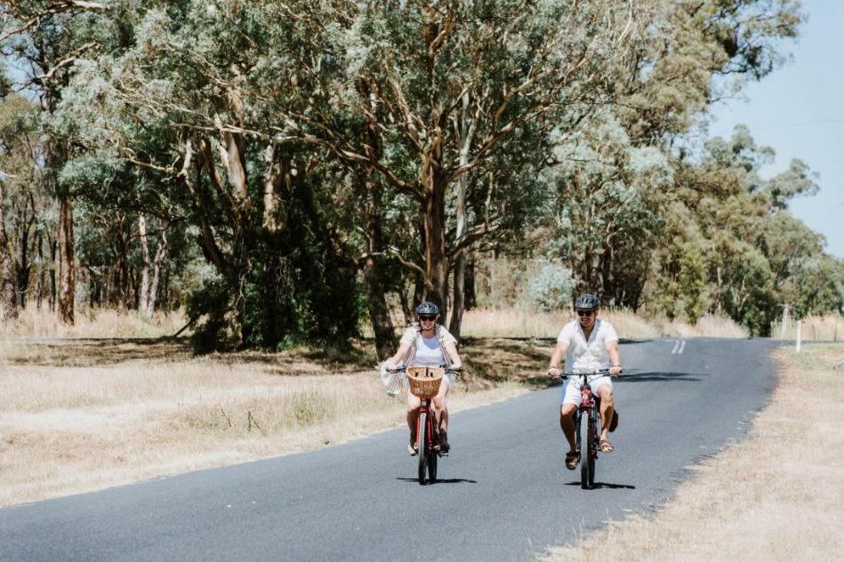
No bikes this time, but they are a popular way to get around Mudgee.
Now popping up are more accommodation providers that promise to get you back to nature.
Luxury tents may sound like an oxymoron, but they are perfectly realised at Evamor Valley, on the property of entrepreneurial couple Charmaine and Chad Hurrell.
Constructed from steel and stretched khaki canvas, a half dozen of them are dotted around a small dam at Evamor – named for the couple’s daughters Eva and Morgan. With hardwood floors, rainfall showers, kitchenettes and king-size beds draped in earthy linens, they are the perfect place to cosplay as campers but without sacrificing comfort.
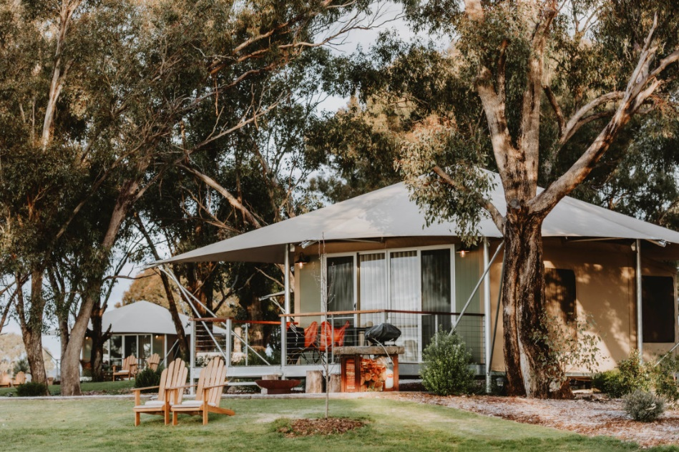
The stretched khaki canvas and steel structures look out onto the property’s idyllic dam. Amber Creative
The Hurrells, who both grew up in Mudgee, bought the property in 2016. Inspired by family camping trips in Tasmania, they put up three tents and began accepting guests in 2021. Three newer plots opened just over a month ago. The tents are quite close to each other, but newly landscaped gardens with infant scrubs promise more privacy and seclusion in the future. The tents have no Wi-Fi, television or clocks.
“It’s really based on wellness and getting back to nature and disconnecting,” says Charmaine. “We wanted it to be that camping vibe but luxurious, without going over the top and feeling cluttered. We didn’t want to overload the senses.”
Advertisement
Cue soft sheets, a stone sink, golden taps, earthy tones, woven rugs and tan leather.
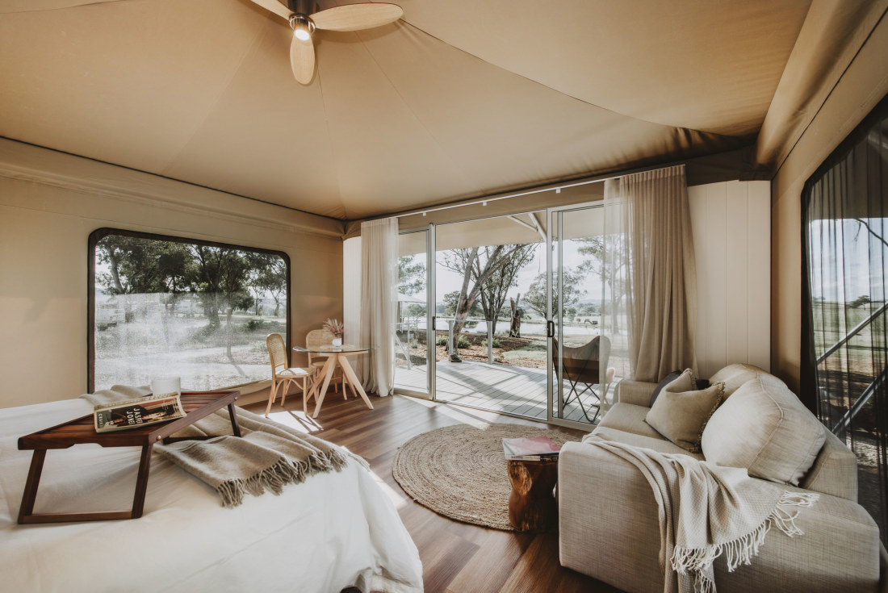
A camping vibe but luxuriously appointed. Amber Creative
Guests are encouraged to walk the 34-hectare property, which is described as a working farm, although it is currently resting after prior periods raising sheep and cattle. A stroll down the hill past some rusty remnants from Mudgee’s founding Cox families brings you to the Cudgegong River.
The sun rises behind the tent so a sleep-in, snuggled into the downy doona, is imminently possible. Instead, we workaholic parents of two small children wake with first light and enjoy the serenity.
Wide sliding doors are a window to mist rising above the dam’s glass-like stillness and golden light glinting off the hardwood bar on the verandah. Once up and wrapped in the fluffy robes supplied, we slip out into the cool morning with our coffees to silently take in the rosellas, galahs and budgerigars picking around for morning sustenance.
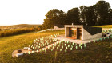

RELATED

Is this the most romantic country retreat in Australia?
After brunching at The Coffee House at Parkview – which does a solid flat white and a granola with roast peaches and berry compote that’s bursting with colour and sweetness, we hit the road for our only rush of the weekend.
Keen to try as much of Mudgee’s produce as possible but also yearning to spend maximum time lounging on the tent’s verandah, we pick an ad-hoc trail around some of the town’s top foodie providores.
Some of the best include Aril Estate, for salty tapenade and extra virgin olive oil – for dipping olive.a.twist sourdough grabbed from the Mudgee Corner Store – and High Valley Cheese Co, which makes a funky rouge, (a semi-soft cheese with an orangy-red washed rind) that oozes flavour.
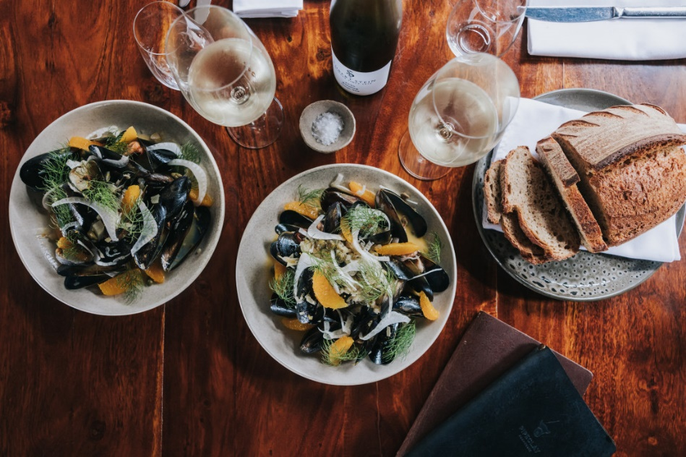
Dining at Pipeclay Pumphouse on the grounds of the Robert Stein Winery.
Advertisement
Small goods’ lovers should not miss Robert Stein Winery’s cellar door, where you can buy the ingredients to replicate a charcuterie board that was the highlight of the previous night’s dinner at Pipeclay Pumphouse. The restaurant, with a relaxed pavilion overlooking the grounds of the winery, imaginatively heroes local, seasonal produce.
Surrounding the vineyards are cattle and sheep and, a little further afield, free-range pigs are raised to create Stein Farm produce such as salamis and prosciutto.
At this point, we have the only minor stress of the weekend: We’re running late for lunch at Zin House, a hatted regional dining superstar.
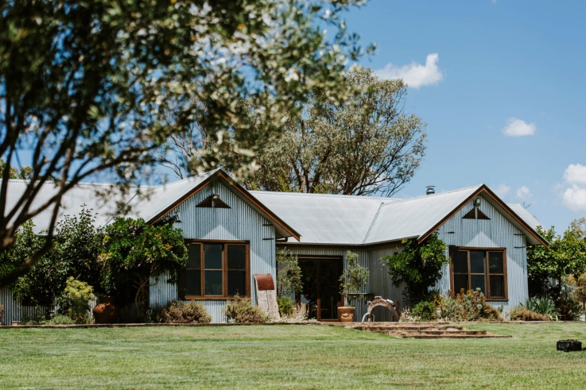
The corrugated iron-clad Zin House restaurant, which used to be the Lowe family home.
No one is perturbed as we jog up the garden path and into the corrugated iron-clad former farmhouse. We are taken to a sunny window table and told to settle in. “Lunch is at least three hours,” says our waiter Roberto, “so I hope you have no plans this afternoon.”
Again, we’ve found a spot to sit back and soak in some stunning surrounds.
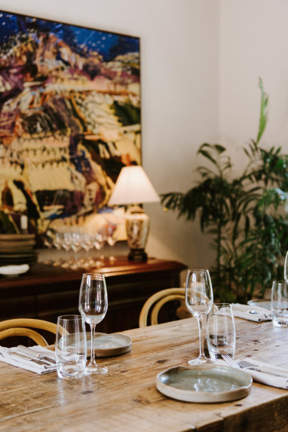
The ultimate long lunch destination.
Zin House is the creation of Kim Currie and David Lowe, whose family have lived and worked on the property for six generations. The restaurant is named for a zinfandel wine made by the Lowe Family Wine Co from grapes harvested from vines we can see from our spot. This hero drop is paired with the third course, a punchy tomato kimchi threaded through pappardellee… but let’s not get ahead of ourselves.
The six-course menu (plus in-between surprises) is set, and matched with local wines, except for a pinot noir produced by one Lowe son who’s decamped to Tassie. The dining room has grand oak communal tables filled with affable groups and cosier nooks for couples. Sumptuous bunches of freshly picked flowers and foliage dot the room and the high walls are covered with bold artworks.
Head chef Kyle Bowett ensures the dining lives up to the location by turning out thoughtful, delicate dishes using produce from a market garden on site and other nearby suppliers.
Advertisement
The sweet medley of rockmelon, pickled apple and almond milk, spiked with tingling mint is a refreshing starter and the low and slow-cooked beef at main is tender with golden mustard carrots.
Perhaps the greatest innovation at Zin is the mandatory walk between courses four (pasta) and five (beef). Guests are ushered outside to stroll through the market garden, down around The Shed, an old artist’s studio turned boutique accommodation, and back to the lawn to relax.
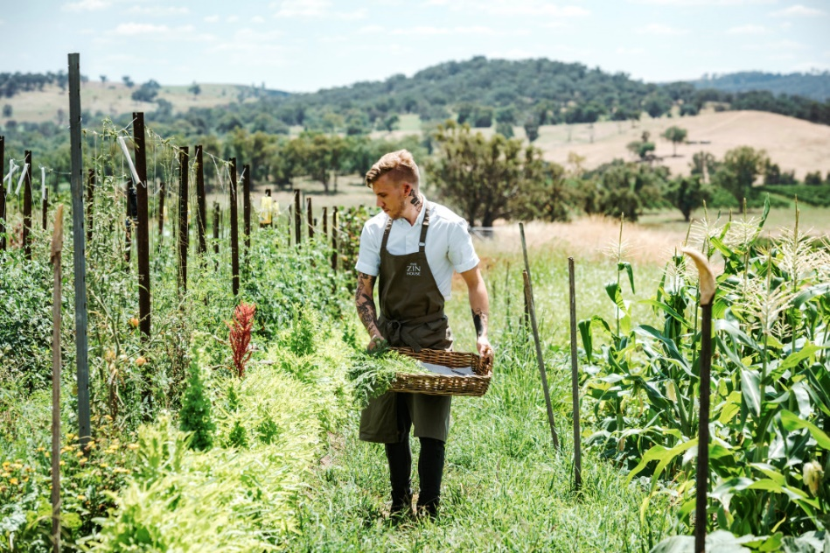
Head chef Kyle Bowett strolling the market garden at Zin House.
It makes perfect sense, of course, to make room for the cheese, dessert and petit fours to come. But it is also another reminder to soak up the outdoors while you are in Mudgee.
Hours later we return to our tent, satiated. There’s no need for the afternoon nibbles, but we still have plenty of appetite for wandering and wondering. And another bath.
The author was a guest of Evamor Valley and Mudgee Region Tourism.

Need to know
- Evamor Valley | Rates from $490 a night during the week, up to $630 a night on weekends.
- Zin House | Open for lunch Thursday to Monday and Saturday dinner. Six-course menu $155 with optional matching wines for $95.
- Pipeclay Pumphouse | Open for dinner Thursday to Saturday and lunch Friday to Sunday. Six-course menu $95 with optional matching wines from $50.

